Circuit Switching
In circuit switching network dedicated channel has to be established before
the call is made between users. The channel is reserved between the users
till the connection is active. For half duplex communication, one channel is
allocated and for full duplex communication, two channels are allocated.
It is mainly used for voice communication requiring real time services
without any much delay

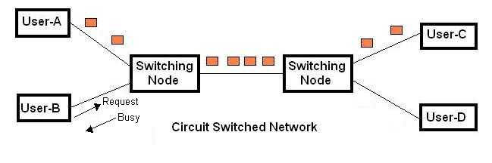

Packet Switching

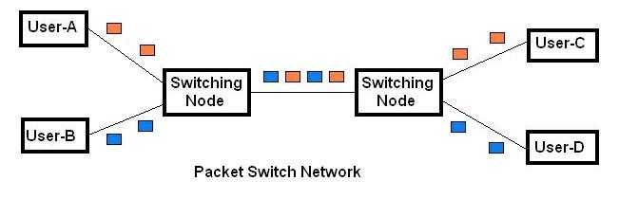
In packet switching network unlike CS network, it is not required to establish the connection initially. The connection/channel is available to use by many users. But when capacity or number of users increases then it will lead to congestion in the network

Comparison between CS vs. PS networks
- As shown above in Packet switched (PS) networks quality of service (QoS) is not guaranteed while in circuit switched (CS) networks quality is guaranteed.
- PS is used for time insensitive applications such as internet/email.
- In CS even if user is not talking the channel cannot be used by any other users, this will waste the resource capacity at those intervals.
- The example of circuit switched network is PSTN and example of packet switched network is GPRS

